PRMA- [Assignment #2](https://myschool.ru.is/myschool/?Page=LMS&ID=16&fagID=27322&View=52&ViewMode=0&verkID=51475&Tab=)

**Question 1 - Item Response Functions and Person Estimates**

1. Which item was the easiest item and which item was the hardest?

The easiest item was item 5 and the hardest item was item 10.

 (b) Provide a 95% confidence interval for the easiest item and interpret it.

Item 5 has the discrimination of -1,6, the Standard Error 0,13

-1,6+1.96*0.13=0,0468

1. Provide a plot that contains both the easiest and the hardest item.

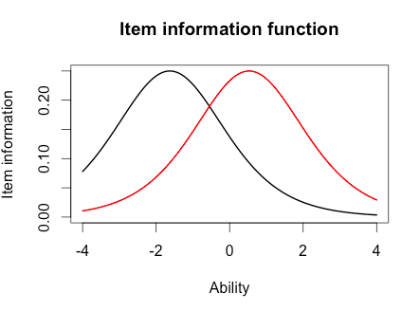

(d) What would we expect the probability of a correct response would be for someone who had an ability score of 0 for these two items?

You can look at the plot (below this answer) and see that the black line (item 5) is easier than the red line (item 10) and if a person has a 0 ability the probability is around 0.4 (40%) for item 10 and around 0.8 (80%) for item 5.

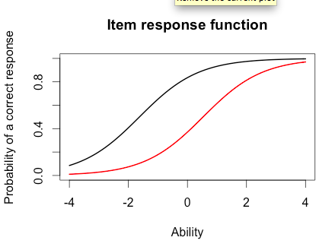

(e) What was the score of the person who did the best on the test? What was the score of the person who did the worst on the test?

Maximum was 3.999921 (student 49) and minimum was -3.999947 (student 393)

(f) Provide a 95% confidence interval for the estimated ability for the student who did the best on the test and interpret it.

3.9+1.96*2.2=8.212

The students (number 49) had the item estimate of 3,99 and a standard error of 2,2. The 95% confidence interval for the estimated ability for student nr.49 was 8,212

**Question 2 - Information**

For this question, you will choose three items to investigate.

1. Please state the three items you selected.

Item 1, item 14 and item 16

1. Provide a plot that contains these three items’ information functions.

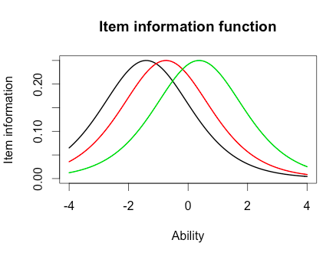

1. What is the same about these items’ information functions? What is different? Hint: This can be a very short answer.

The have the same discrimination.

1. Provide a plot of the test information function.

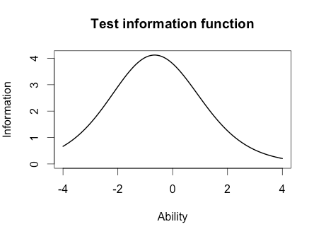

(e) Where is the majority of the information for this test located?

-0.5 or in the range from -1 to 0.

Finally, you will need to run a 2-PL.

**Question 3 - Comparing the 2-PL**

1. Which item had the highest discrimination? Which one had the lowest discrimination?

The highest was item 8, and the lowest was item 12.

1. Are the items that were the easiest and hardest in the Rasch model, also the easiest and hardest  in the 2-PL?

No the are not.

1. What is the correlation between the ability estimates on the Rasch model and the 2-PL?

The correlation in the 2-PL model is 0.9709497

If your interest was solely on estimating person abilities, do you think you would draw the same conclusions from both models?

Yes we would draw the same conclusions from both models.

Why?

When comparing the same items in different models, the discriminations was different but ability was the same as you can see on the plots.

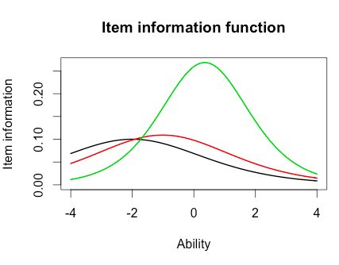

1. Provide a plot of the item information function for the three items you selected in Question 2 but this time for the 2-PL model. (1 point)



(e) For the 2-PL model, how do the item information functions for these items differ?

Two have the same discrimination which is low, but one has a higher discrimination.

(f) How do the 2-PL item information functions from these items differ from their Rasch item information functions?

The discriminations were equally high in Rasch but different in 2-PL.

R version 3.1.2 (2014-10-31) -- "Pumpkin Helmet"

Copyright (C) 2014 The R Foundation for Statistical Computing

Platform: x86_64-apple-darwin10.8.0 (64-bit)

R is free software and comes with ABSOLUTELY NO WARRANTY.

You are welcome to redistribute it under certain conditions.

Type 'license()' or 'licence()' for distribution details.

Natural language support but running in an English locale

R is a collaborative project with many contributors.

Type 'contributors()' for more information and

'citation()' on how to cite R or R packages in publications.

Type 'demo()' for some demos, 'help()' for on-line help, or

'help.start()' for an HTML browser interface to help.

Type 'q()' to quit R.

During startup - Warning messages:

1: Setting LC_CTYPE failed, using "C"

2: Setting LC_COLLATE failed, using "C"

3: Setting LC_TIME failed, using "C"

4: Setting LC_MESSAGES failed, using "C"

5: Setting LC_MONETARY failed, using "C"

> install.packages("irtoys")

trying URL 'http://cran.rstudio.com/bin/macosx/contrib/3.1/irtoys_0.1.7.tgz'

Content type 'application/x-gzip' length 127042 bytes (124 Kb)

opened URL

==================================================

downloaded 124 Kb

tar: Failed to set default locale

The downloaded binary packages are in

/var/folders/w3/gjjdb8t56_qd4kx3lm3pwpbc0000gn/T//RtmpCEoy60/downloaded_packages

> library("irtoys")

Loading required package: sm

Package 'sm', version 2.2-5.4: type help(sm) for summary information

Loading required package: ltm

Loading required package: MASS

Attaching package: 'MASS'

The following object is masked from 'package:sm':

muscle

Loading required package: msm

Loading required package: polycor

Loading required package: mvtnorm

Loading required package: sfsmisc

> ## ------------------------------------------------------------------------

> getwd()

[1] "/Users/SiggaFanndal"

> ## ------------------------------------------------------------------------

> # This actually runs the model

> rasch_model <- est(Scored, model="1PL", engine="ltm", rasch = TRUE)

> #

> # Estimated Parameters

> #

> est_params <- rasch_model$est

> colnames(est_params) <- c("Discrimination", "Difficulty", "Guessing")

> rownames(est_params) <- paste("Item", 1:18)

> est_params

Discrimination Difficulty Guessing

Item 1 1 -1.40938612 0

Item 2 1 -0.35055656 0

Item 3 1 -0.90318970 0

Item 4 1 -0.97412011 0

Item 5 1 -1.62671110 0

Item 6 1 0.02533657 0

Item 7 1 -0.41418545 0

Item 8 1 -0.87993298 0

Item 9 1 -0.91498121 0

Item 10 1 0.52959427 0

Item 11 1 -1.17125435 0

Item 12 1 -0.04749604 0

Item 13 1 0.15008663 0

Item 14 1 -0.74253017 0

Item 15 1 -0.74245332 0

Item 16 1 0.36963876 0

Item 17 1 -0.84513136 0

Item 18 1 -1.45145349 0

> #

> # Standard Errors

> #

> est_se <- rasch_model$se

> colnames(est_se) <- c("Discrimination SE", "Difficulty SE", "Guessing SE")

> rownames(est_se) <- paste("Item", 1:18)

> est_se

Discrimination SE Difficulty SE Guessing SE

Item 1 NA 0.1267448 0

Item 2 NA 0.1128011 0

Item 3 NA 0.1178581 0

Item 4 NA 0.1188426 0

Item 5 NA 0.1320051 0

Item 6 NA 0.1118476 0

Item 7 NA 0.1131572 0

Item 8 NA 0.1175527 0

Item 9 NA 0.1180162 0

Item 10 NA 0.1136598 0

Item 11 NA 0.1220123 0

Item 12 NA 0.1118797 0

Item 13 NA 0.1119630 0

Item 14 NA 0.1159197 0

Item 15 NA 0.1159189 0

Item 16 NA 0.1126941 0

Item 17 NA 0.1171115 0

Item 18 NA 0.1276902 0

> #

> # Plot item response function for items 1, 3, 5

> #

> plot(irf(est_params[c(1,3,5),]), co = NA)

> # you can safely delete co = NA if you want the lines to all be black

> #

> # Estimated abilities

> #

> est_abl <- as.data.frame(mlebme(Scored, ip = est_params))

> min(est_abl$est) # Prints the minimum score

[1] -3.999947

> max(est_abl$est) # Prints the maximum scores

[1] 3.999921

> which.min(est_abl$est) # Prints out the person minimum score

[1] 393

> which.max(est_abl$est) # Prints out the person with the maximum score

[1] 49

> # To find out score for person 200

> est_abl[200,]

est sem n

200 -0.6390908 0.492458 18

> #

> # Plot Item Information Function for items 1, 3, 5

> #

> plot(iif(est_params[c(1,3,5),]), co = NA)

> #

> # Plot Test Information Function

> #

> plot(tif(est_params))

> plot(iif(est_params[c(5,10),]), co = NA)

> plot(iif(est_params[c(5),]), co = NA)

> View(est_params)

> View(est_se)

> View(est_abl)

> plot(irf(est_params[c(5,10),]), co = NA)

> plot(irf(est_params[c(1,14,16),]), co = NA)

> plot(iif(est_params[c(1,14,16),]), co = NA)

> plot(tif(est_params[c(1,14,16),]), co = NA)

> plot(tif(est_params))

> # This actually runs the model

> twopl_model <- est(Scored, model="2PL", engine="ltm")

> #

> # Estimated Parameters

> #

> twopl_params <- twopl_model$est

> colnames(twopl_params) <- c("Discrimination", "Difficulty", "Guessing") rownames(twopl_params) <- paste("Item", 1:18)

Error: unexpected symbol in "colnames(twopl_params) <- c("Discrimination", "Difficulty", "Guessing") rownames"

> twopl_params

[,1] [,2] [,3]

Item 1 0.6326689 -2.00058101 0

Item 2 1.5469622 -0.26815483 0

Item 3 1.2534918 -0.77297206 0

Item 4 0.9842598 -0.97706755 0

Item 5 1.6407242 -1.19389580 0

Item 6 1.4702029 0.01833431 0

Item 7 0.5632837 -0.65124651 0

Item 8 2.2881772 -0.56753253 0

Item 9 1.8004066 -0.64761748 0

Item 10 1.1142107 0.48542889 0

Item 11 1.0344119 -1.13363005 0

Item 12 0.3329130 -0.12951933 0

Item 13 0.3369968 0.36344671 0

Item 14 0.6608229 -1.01479867 0

Item 15 1.5980393 -0.55640285 0

Item 16 1.0362116 0.35459121 0

Item 17 1.8591845 -0.59017915 0

Item 18 1.2808752 -1.22177042 0

> #

> # Estimated abilities

> #

> twopl_abl <- as.data.frame(mlebme(Scored, ip = twopl_params))

> # Correlation between the ability estimates

> cor(twopl_abl$est,est_abl$est)

[1] 0.9709497

>

>

> colnames(twopl_params) <- c("Discrimination", "Difficulty", "Guessing") rownames(twopl_params) <- paste("Item", 1:18)

Error: unexpected symbol in "colnames(twopl_params) <- c("Discrimination", "Difficulty", "Guessing") rownames"

> # This actually runs the model

> twopl_model <- est(Scored, model="2PL", engine="ltm")

> #

> # Estimated Parameters

> #

> twopl_params <- twopl_model$est

> colnames(twopl_params) <- c("Discrimination", "Difficulty", "Guessing")

> rownames(twopl_params) <- paste("Item", 1:18)

> twopl_params

Discrimination Difficulty Guessing

Item 1 0.6326689 -2.00058101 0

Item 2 1.5469622 -0.26815483 0

Item 3 1.2534918 -0.77297206 0

Item 4 0.9842598 -0.97706755 0

Item 5 1.6407242 -1.19389580 0

Item 6 1.4702029 0.01833431 0

Item 7 0.5632837 -0.65124651 0

Item 8 2.2881772 -0.56753253 0

Item 9 1.8004066 -0.64761748 0

Item 10 1.1142107 0.48542889 0

Item 11 1.0344119 -1.13363005 0

Item 12 0.3329130 -0.12951933 0

Item 13 0.3369968 0.36344671 0

Item 14 0.6608229 -1.01479867 0

Item 15 1.5980393 -0.55640285 0

Item 16 1.0362116 0.35459121 0

Item 17 1.8591845 -0.59017915 0

Item 18 1.2808752 -1.22177042 0

> #

> # Estimated abilities

> #

> twopl_abl <- as.data.frame(mlebme(Scored, ip = twopl_params))

> # Correlation between the ability estimates

> cor(twopl_abl$est,est_abl$est)

[1] 0.9709497

>

>

> #

> # Plot Item Information Function for items 1, 3, 5 #

> plot(iif(twopl_params[c(1,3,5),]), co = NA)

> plot(iif(twopl_params[c(1,14,16),]), co = NA)

>

(For the confidence interval questions)

R version 3.1.2 (2014-10-31) -- "Pumpkin Helmet"

Copyright (C) 2014 The R Foundation for Statistical Computing

Platform: x86_64-apple-darwin10.8.0 (64-bit)

R is free software and comes with ABSOLUTELY NO WARRANTY.

You are welcome to redistribute it under certain conditions.

Type 'license()' or 'licence()' for distribution details.

Natural language support but running in an English locale

R is a collaborative project with many contributors.

Type 'contributors()' for more information and

'citation()' on how to cite R or R packages in publications.

Type 'demo()' for some demos, 'help()' for on-line help, or

'help.start()' for an HTML browser interface to help.

Type 'q()' to quit R.

During startup - Warning messages:

1: Setting LC_CTYPE failed, using "C"

2: Setting LC_COLLATE failed, using "C"

3: Setting LC_TIME failed, using "C"

4: Setting LC_MESSAGES failed, using "C"

5: Setting LC_MONETARY failed, using "C"

[Workspace loaded from ~/.RData]

> install.packages("irtoys")

trying URL 'http://cran.rstudio.com/bin/macosx/contrib/3.1/irtoys_0.1.7.tgz'

Content type 'application/x-gzip' length 127042 bytes (124 Kb)

opened URL

==================================================

downloaded 124 Kb

tar: Failed to set default locale

The downloaded binary packages are in

/var/folders/hj/tcdy84xn6p9731ytpl88vzmw0000gn/T//Rtmpg0BpzM/downloaded_packages

> library("irtoys")

Loading required package: sm

Package 'sm', version 2.2-5.4: type help(sm) for summary information

Loading required package: ltm

Loading required package: MASS

Attaching package: 'MASS'

The following object is masked from 'package:sm':

muscle

Loading required package: msm

Loading required package: polycor

Loading required package: mvtnorm

Loading required package: sfsmisc

> getwd()

[1] "/Users/asruna"

> rasch_model <- est(Scored, model="1PL", engine="ltm", rasch = TRUE)

> est_params <- rasch_model$est

> colnames(est_params) <- c("Discrimination", "Difficulty", "Guessing")

> rownames(est_params) <- paste("Item", 1:18)

> est_params

Discrimination Difficulty Guessing

Item 1 1 -1.40938612 0

Item 2 1 -0.35055656 0

Item 3 1 -0.90318970 0

Item 4 1 -0.97412011 0

Item 5 1 -1.62671110 0

Item 6 1 0.02533657 0

Item 7 1 -0.41418545 0

Item 8 1 -0.87993298 0

Item 9 1 -0.91498121 0

Item 10 1 0.52959427 0

Item 11 1 -1.17125435 0

Item 12 1 -0.04749604 0

Item 13 1 0.15008663 0

Item 14 1 -0.74253017 0

Item 15 1 -0.74245332 0

Item 16 1 0.36963876 0

Item 17 1 -0.84513136 0

Item 18 1 -1.45145349 0

> est_se <- rasch_model$se

> colnames(est_se) <- c("Discrimination SE", "Difficulty SE", "Guessing SE")

> rownames(est_se) <- paste("Item", 1:18)

> est_se

Discrimination SE Difficulty SE Guessing SE

Item 1 NA 0.1267448 0

Item 2 NA 0.1128011 0

Item 3 NA 0.1178581 0

Item 4 NA 0.1188426 0

Item 5 NA 0.1320051 0

Item 6 NA 0.1118476 0

Item 7 NA 0.1131572 0

Item 8 NA 0.1175527 0

Item 9 NA 0.1180162 0

Item 10 NA 0.1136598 0

Item 11 NA 0.1220123 0

Item 12 NA 0.1118797 0

Item 13 NA 0.1119630 0

Item 14 NA 0.1159197 0

Item 15 NA 0.1159189 0

Item 16 NA 0.1126941 0

Item 17 NA 0.1171115 0

Item 18 NA 0.1276902 0

> plot(irf(est_params[c(5,10),]), co = NA)

> est_abl <- as.data.frame(mlebme(Scored, ip = est_params))

> min(est_abl$est) # Prints the minimum score

[1] -3.999947

> max(est_abl$est) # Prints the maximum scores

[1] 3.999921

> which.min(est_abl$est) # Prints out the person minimum score

[1] 393

> which.max(est_abl$est) # Prints out the person with the maximum score

[1] 49

> est_abl[200,]

est sem n

200 -0.6390908 0.492458 18

> plot(iif(est_params[c(1,14,16),]), co = NA)

> plot(tif(est_params))

> twopl_model <- est(Scored, model="2PL", engine="ltm")

> twopl_params <- twopl_model$est

> colnames(twopl_params) <- c("Discrimination", "Difficulty", "Guessing")

> rownames(twopl_params) <- paste("Item", 1:18)

> twopl_params

Discrimination Difficulty Guessing

Item 1 0.6326689 -2.00058101 0

Item 2 1.5469622 -0.26815483 0

Item 3 1.2534918 -0.77297206 0

Item 4 0.9842598 -0.97706755 0

Item 5 1.6407242 -1.19389580 0

Item 6 1.4702029 0.01833431 0

Item 7 0.5632837 -0.65124651 0

Item 8 2.2881772 -0.56753253 0

Item 9 1.8004066 -0.64761748 0

Item 10 1.1142107 0.48542889 0

Item 11 1.0344119 -1.13363005 0

Item 12 0.3329130 -0.12951933 0

Item 13 0.3369968 0.36344671 0

Item 14 0.6608229 -1.01479867 0

Item 15 1.5980393 -0.55640285 0

Item 16 1.0362116 0.35459121 0

Item 17 1.8591845 -0.59017915 0

Item 18 1.2808752 -1.22177042 0

> twopl_abl <- as.data.frame(mlebme(Scored, ip = twopl_params))

> cor(twopl_abl$est,est_abl$est)

[1] 0.9709497

> plot(iif(twopl_params[c(1,14,16),]), co = NA)

> est_se

Discrimination SE Difficulty SE Guessing SE

Item 1 NA 0.1267448 0

Item 2 NA 0.1128011 0

Item 3 NA 0.1178581 0

Item 4 NA 0.1188426 0

Item 5 NA 0.1320051 0

Item 6 NA 0.1118476 0

Item 7 NA 0.1131572 0

Item 8 NA 0.1175527 0

Item 9 NA 0.1180162 0

Item 10 NA 0.1136598 0

Item 11 NA 0.1220123 0

Item 12 NA 0.1118797 0

Item 13 NA 0.1119630 0

Item 14 NA 0.1159197 0

Item 15 NA 0.1159189 0

Item 16 NA 0.1126941 0

Item 17 NA 0.1171115 0

Item 18 NA 0.1276902 0

> est_abl[200,]

est sem n

200 -0.6390908 0.492458 18

> est_abl[49,]

est sem n

49 3.999921 2.204373 18

> 3.99+1.96*2.2=

+ 3.99+1.96*2.2

Error in 3.99 + 1.96 * 2.2 = 3.99 + 1.96 * 2.2 :

target of assignment expands to non-language object

>